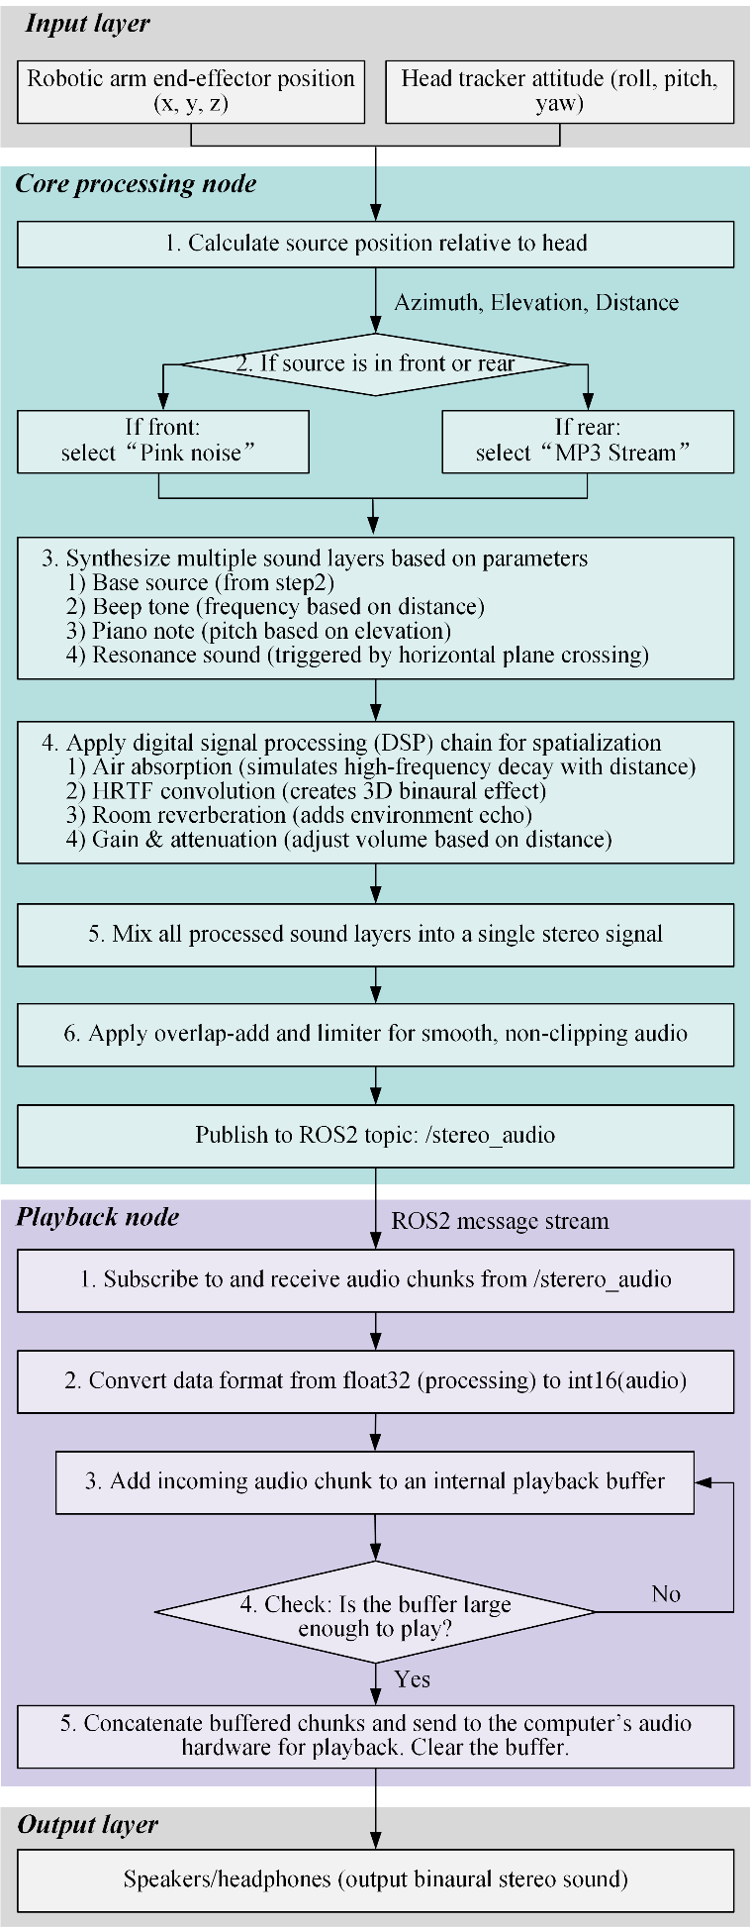

Figure S1: Flowchart of the proprioceptive sonification process. The diagram illustrates the complete signal processing pipeline, starting from the acquisition of the SRL end-effector and user head positions, through the mixed-content audio rendering engine, to the final generation of the binaural audio signal for the headphones.

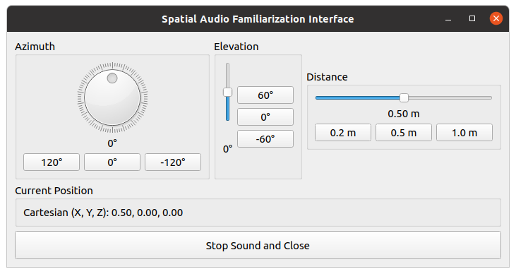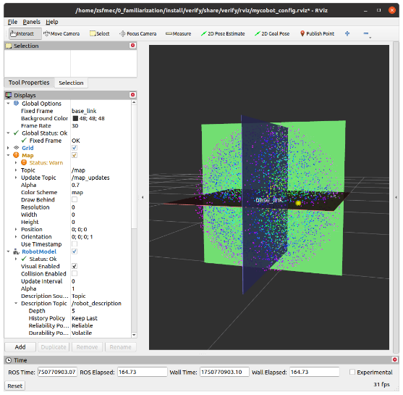

(a) (b)

Fig. S2. The interactive interface for the familiarization and training stage. (a) The Graphical User Interface (GUI) that allows participants to freely manipulate the sound source's position by independently controlling its azimuth, elevation, and distance via three separate panels. (b) The corresponding real-time visualization in RViz, where the sound source (yellow sphere) is shown relative to the participant's head (at the origin). This setup allows participants to actively explore the mapping between the controls, the visual position, and the resulting auditory cues.

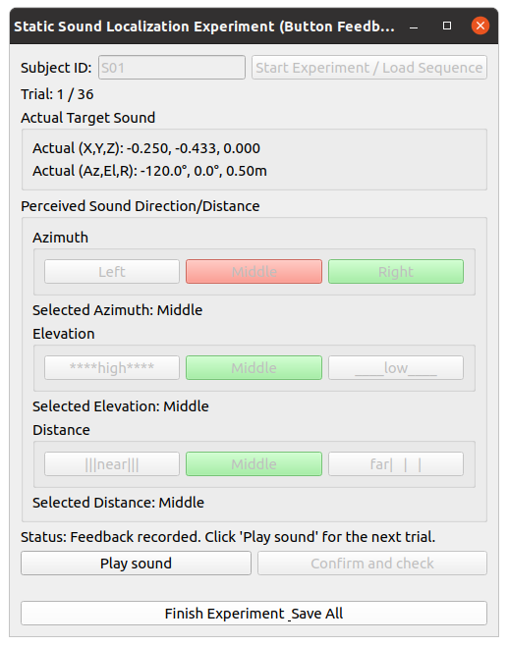

Fig. S3. The interactive interface for the coarse static localization experiment. For each of the 36 trials, a sound is presented from one of nine unique, randomly ordered locations. The interface provides a 3-alternative forced-choice (3-AFC) task for each spatial dimension (azimuth, elevation, and distance). After the participant classifies the perceived location and submits their response, the system provides immediate visual feedback, highlighting the correct (green) and incorrect (red) selections.

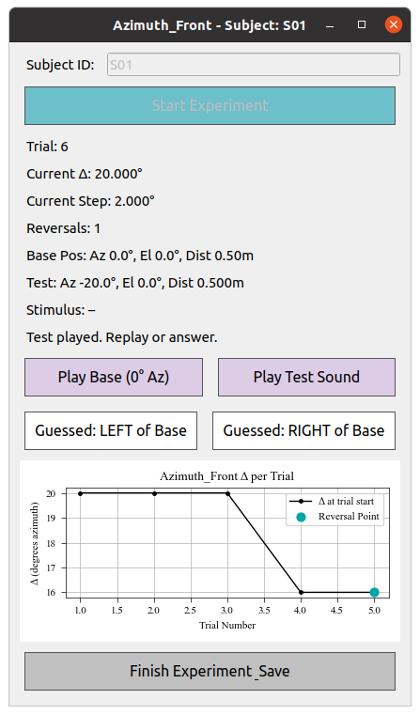

Fig. S4. The interactive interface for the static spatial resolution experiment. The interface facilitates a two-alternative forced-choice (2AFC) task where the participant compares a variable 'test sound' against a fixed 'reference sound'. The reference sound was set to a specific value for each of the six experimental conditions (e.g., 0° for azimuth front, 0.5 m for distance). The position of the test sound is automatically adjusted between trials using a 3-down/1-up adaptive staircase algorithm. The procedure terminates automatically based on one of three conditions: a maximum of 50 trials, the completion of 6 reversals, or when performance stabilizes at the minimum step size.

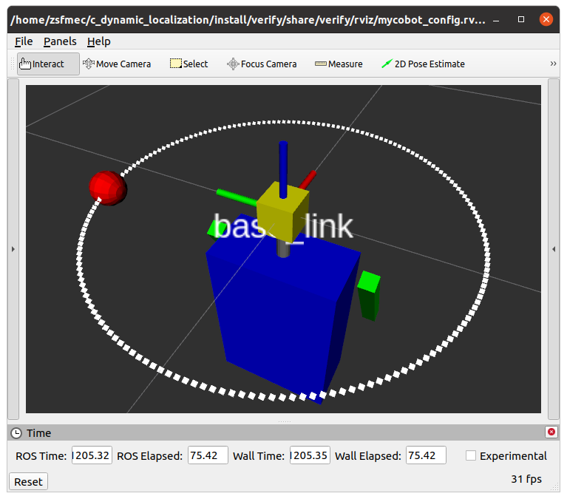

Fig. S5. A screenshot of the visual interface for Experiment 3 (Dynamic-to-Static Localization). The participant's avatar is depicted, showing the head (yellow cube), a forward-direction indicator (red line), torso (blue cube), and arms (green cuboids). The head's rotation in the simulation is mapped to the participant's real-world head movements, tracked by an IMU. The sound source, represented by the red sphere, moves at a constant rate along a predefined trajectory (white dots) until it is stopped at a randomized point by the experimenter, at which time the participant performs the localization task.

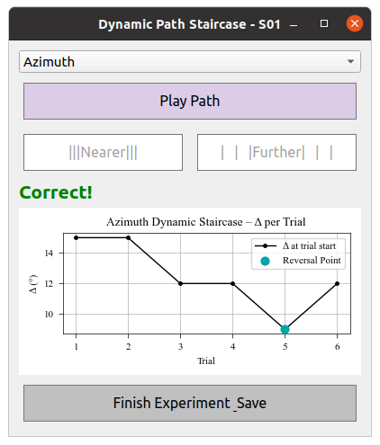

Fig. S6. The interactive interface for the dynamic spatial resolution experiment. The interface facilitates a two-alternative forced-choice (2AFC) task where the participant must identify the direction of a brief, orthogonal displacement from a predefined trajectory. For example, during a horizontal trajectory, this displacement was either forward or backward. The magnitude of this displacement is automatically adjusted between trials using a 2-down/1-up adaptive staircase algorithm to find the perceptual threshold. The procedure terminates automatically based on one of three conditions: a maximum of 50 trials, the completion of 6 reversals, or when performance stabilizes at the minimum step size.